Project Sprint #1

The Solitaire game is described in CS449HomeworkOverview. You should read the description very carefully.

In this assignment, you aim to specify the requirements (i.e., user stories and acceptance criteria) of the target software that allows a human player to play a Solitaire game. These requirements will be fully implemented by the end of sprint 3. The minimum features include choosing the board size and type, starting a new game, making a move, determining if a game is over. The following is a sample GUI layout.

Board size
7
Board Type  - English  - Hexagon  - Diamond | 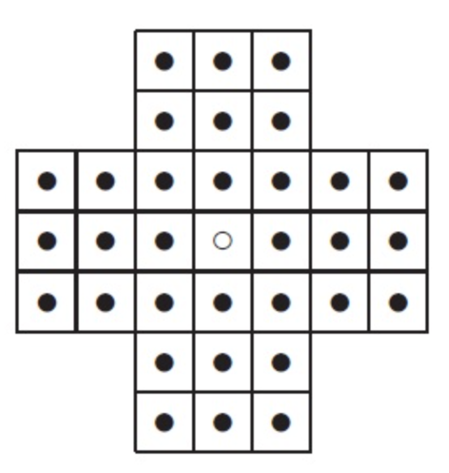 | New Game
Figure 1. Sample GUI layout of the first working program by the end of Sprint 3

Use the following tables to document your user stories and acceptance criteria.

You are required to use the free ChatGPT or another LLM to complete two user stories and two of their respective acceptance criteria. You must ensure that the generated user stories are correct and fix them if not. At the end of the submission, provide screenshots of your LLM prompts and answers, along with the description of errors the LLM made that you had to correct. Points will be deducted if no screenshots/description are provided.

For the other user stories and acceptance criteria, you are not required to use LLM.

- User Stories (3 points)

- User Story Template: As a <role>, I want <goal> [so that <benefit>]

ID | User Story Name | User Story Description | Priority | Estimated effort (hours)
1 | Choose a board size | As a player, I want to choose the board size so that I can play the game using the board size I prefer. | High | 2 hours
2 | Choose the board type | As a player, I want to choose the board type so that I can play using the type of Peg Solitaire board I prefer. | High | 2 hours
3 | Start a new game of the chosen board size and type | As a player, I want to start a new game using my chosen board size and board type so that I can play the game with my selected settings | High | 2 hours
4 | Make a move in a game | As a player, I want to make a move in the game so that I can play Peg Solitaire | High | 4 hours
5 | A game is over | As a player, I want the game to determine when it is over so that I know when I have finished playing | High | 3 hours

- Acceptance Criteria (AC) (12 points): Add/delete rows as needed.

User Story ID and Name | AC  ID | Description of Acceptance Criterion | Status (completed, toDo, inPprogress)
1. Choose a board size | 1.1 | AC 1.1 Display board size options  Given the player is on the game setup screen  When the player views the board size options  Then the available board size options are displayed | toDo
1. Choose a board size | 1.2 | AC 1.2 Select a board size  Given the available board sizes are displayed  When the player selects a board size  Then the selected board size is saved as the board size for the game | toDo
1. Choose a board size | 1.3 | AC 1.3 Change the selected board size  Given the player has selected a board size  When the player selects a different board size  Then the newly selected board size replaces the previous selection | toDo
2. Choose the board type | 2.1 | AC 2.1 Display board type options  Given the player is on the game setup screen  When the player views the board type options  Then the available board types are displayed | toDo
2. Choose the board type | 2.2 | AC 2.2 Select a board type  Given the available board types are displayed  When the player selects a board type  Then the selected board type is saved as the board type for the game | toDo
2. Choose the board type | 2.3 | AC 2.3 Change the selected board type  Given the player has selected a board type  When the player selects a different board type  Then the newly selected board type replaces the previous selection | toDo
3.Start a new game of the chosen board size and type | 3.1 | AC 3.1 Start a new game  Given the player has selected a board size and board type  When the player chooses a new game  Then a new game starts using the selected board size and board type | toDo
3.Start a new game of the chosen board size and type | 3.2 | AC 3.2 New game displays the selected board  Given the player has selected a board size and board type  When the player starts a new game  Then the game displays a board matching the selected size and type | toDo
3.Start a new game of the chosen board size and type | 3.3 | AC 3.3 Start another game  Given a game is currently in progress  When the player starts a new game  Then the current game is replaced with a new game using the selected board size and type | toDo
4. Make a move in a game | 4.1 | AC 4.1 Select a piece  Given a game has been started  When the player selects a piece on the board  Then the selected piece is identified as the piece the player wants to move | toDo
4. Make a move in a game | 4.2 | AC 4.2 Make a move  Given a game is in progress and the player has selected a piece  When the player makes a move  Then the board is updated to reflect the move | toDo
4. Make a move in a game | 4.3 | AC 4.3 Continue playing after a move  Given a move has been made  When the board is updated  Then the player can make another move if the game is not over | toDo
5. A game is over | 5.1 | AC 5.1 Determine when the game is over  Given a game is in progress  When the player makes a move  Then the game determines whether the game is over | toDo
5. A game is over | 5.2 | AC 5.2 Notify the player when the game is over  Given the game has reached an end condition  When the game determines that it is over  Then the player is notified that the game is over | toDo
5. A game is over | 5.3 | AC 5.3 Prevent further moves after the game is over  Given the game is over  When the player attempts to make another move  Then the game does not allow another move | toDo

LLM Output:

